CMIS 410 Final Idea and Images

Kraig Nelson

1/29/2023

The fictitious business I plan on using for our final project is Nelson’s Snow Removal. I find this easy to use as I formerly worked for a lawn care/snow removal company in high school. So, this is a familiar business to me.

First Image: Snowplow

Searched for snowplow on Google.com/images and used the Creative Commons Licenses tool to filter.

<https://www.flickr.com/photos/26329029@N06/12488358945>

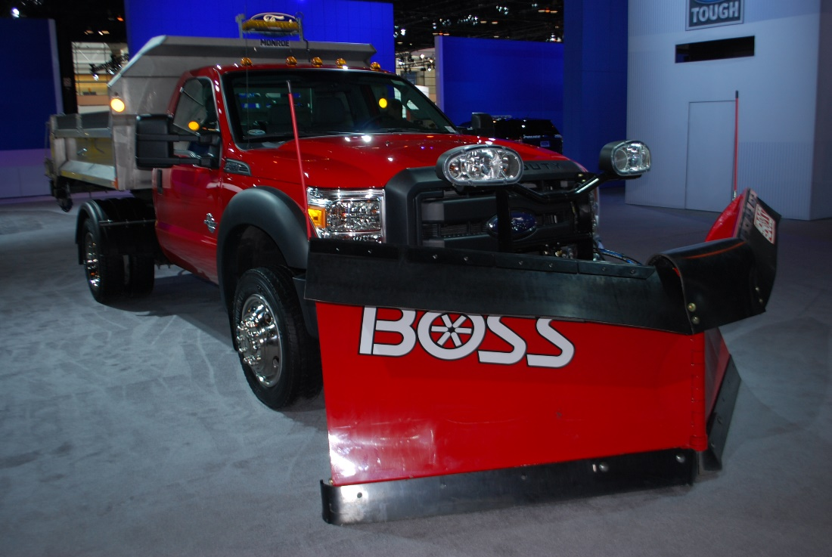

Second Image: Snow Blower

Searched snowblower on Google.com/images and used the Creative Commons Licenses tool to filter.

<https://www.flickr.com/photos/calliope/3131202025>

